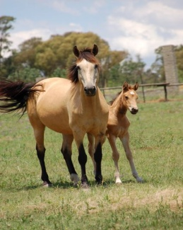
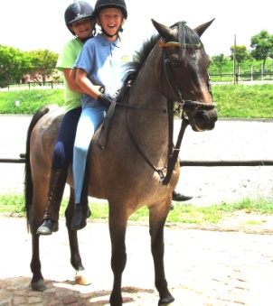
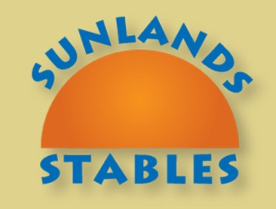

Easter Holiday Camp

We are offering a fun filled camp where children can enjoy farm life, riding, explore their own capabilities & make a host of new friends.

Sunlands Farm is a riding yard and working farm situated in the lovely Sun Valley district,
In Kyalami area catering for young people between the ages of 5 and 18.

4 Day Sleepover Camp Total cost R1200.00 (10%discount for contract clients)
or Daily rate R350 (we provide lunch and snacks,collect before 6pm )
(discounted rates for siblings please discuss)

provisional dates subject to sufficient numbers
Tuesday 22nd April to Friday 25th April
Tuesday 29th April to Friday 2nd May

See website www.sunlandsfarm.co.za for directions
Booking Essential – 24 Hour Supervision – Qualified horse riding Tuition for all levels, previous riding experience not necessary – All activities are supervised by counsellors.

Activities: Pony Rides, Riding lessons, Quizzes, Games, Hikes, Treasure Hunts, Picnics Swimming, Tennis, Team Building, Bonfires, Arts & Crafts.

For more information contact Claudia or Sarah on dvrettas@netactive.co.za

